**Crypto price history over the years**

Many want to make quick money in the crypto space. Of course there are short-term gains, but if you want to be really successful, you should think about 5-10 years in the long term (similar to the stock market).

Why is this? Prices are formed by supply and demand and can be influenced by external influences such as natural disasters, politics and war.

There is also limited historical data in 2022 as many cryptocurrencies are relatively new.

Prices rise and fall - we can try to predict them using chart analysis, but prices in the crypto sector are subject to strong daily fluctuations.

On the time axis, the developments look like this as an example*

**Course development per day**

Cryptocurrencies are subject to strong fluctuations on a daily basis. Prices are difficult to predict.

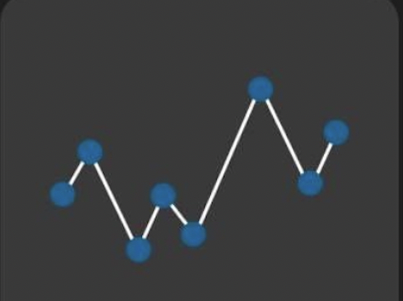

**Course development in years (< 10 years)**

In contrast, it looks better and more stable in the annual view. The daily fluctuations are no longer so significant and the chance of a steady price gain increases.



**Price development from an investment horizon of 10 years**

The longer you want to invest, the more stable the price development will be



You have seen that if you look at prices on a daily basis, there can be high fluctuations, but over the years it evens out.

That's why it pays to think long-term when investing in cryptocurrencies.

*es handelt sich hierbei um Beispiele und zeigt nicht die reale Veränderung